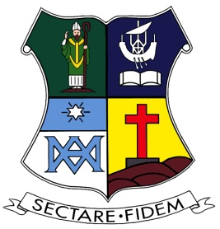

St Patricks College Old Boys Association
Old Boy of the Year - Nomination Form

This award may be granted annually

The award recognises Old Boys who have promoted the betterment of the people of New Zealand, fostered the Marist way of life and carried the principles taught at the St Patrick's Colleges into the community. The recipient is also granted life membership of the association.

Each nomination is considered by the Executive and then a panel consisting of the President of the association and the two Rectors of the colleges recommend the award to the successful candidate acting on their own initiative or on the recommendation of the Executive

Date
Nominator
Nominee
Short Biography

Achievements

Once you have filled this form out, email it to brad.hudson1986@gmail.com

